Python defines type conversion functions to directly convert one data type to another which is useful in day-to-day and competitive programming. This article is aimed at providing information about certain conversion functions.

There are two types of Type Conversion in Python:

1. Implicit Type Conversion
2. Explicit Type Conversion

Let’s discuss them in detail.

**Implicit Type Conversion**

In Implicit type conversion of data types in Python, the Python interpreter automatically converts one data type to another without any user involvement. To get a more clear view of the topic see the below examples.

**Example:**

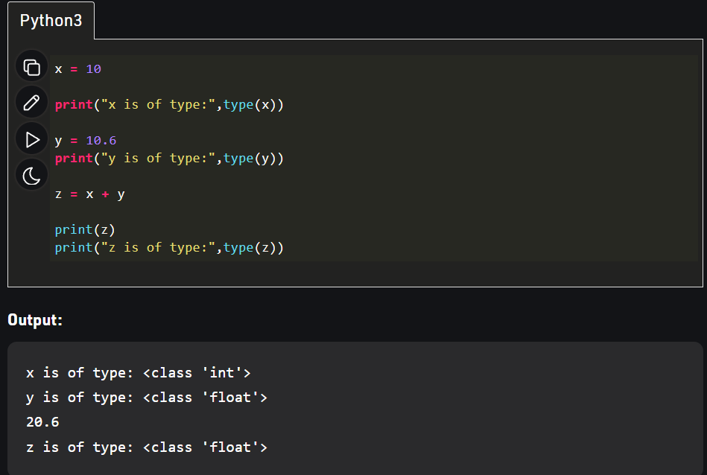

As we can see the data type of ‘z’ got automatically changed to the “float” type while one variable x is of integer type while the other variable y is of float type. The reason for the float value not being converted into an integer instead is due to type promotion that allows performing operations by converting data into a wider-sized data type without any loss of information. This is a simple case of Implicit type conversion in python.

**Explicit Type Conversion**

In Explicit Type Conversion in Python, the data type is manually changed by the user as per their requirement. With explicit type conversion, there is a risk of data loss since we are forcing an expression to be changed in some specific data type.  Various forms of explicit type conversion are explained below:

**1. int(a,** **base)**: This function converts**any data type to integer**. ‘Base’ specifies the**base in which string is** if the data type is a string.  
**2. float()**: This function is used to convert **any data type to a**floating-point**number.**

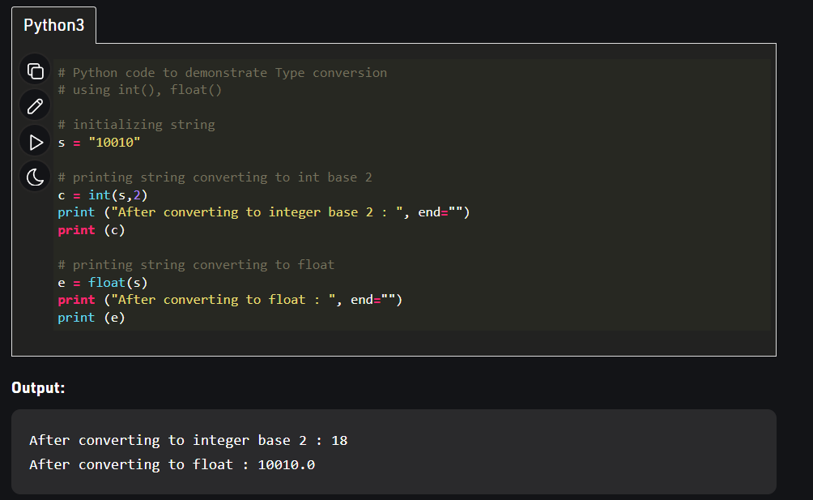

**3. ord() : This function is used to convert a character to integer.  
4. hex() : This function is to convert integer to hexadecimal string.  
5. oct() : This function is to convert integer to octal string.**

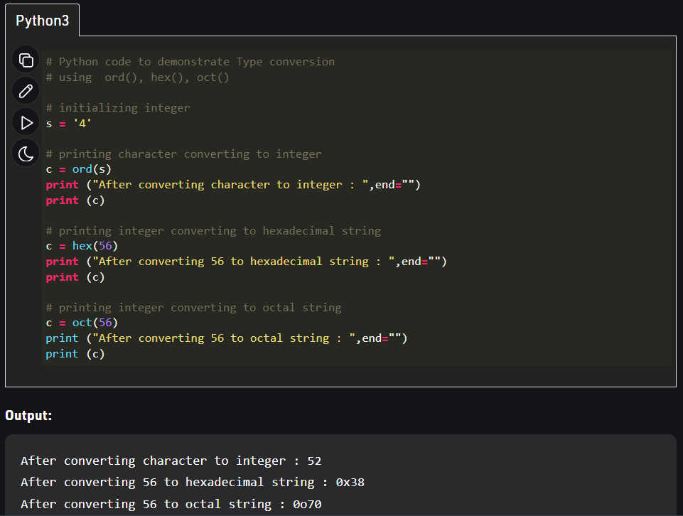

**6. tuple() :**This function is used to **convert to a tuple**.  
**7. set() :**This function returns the **type after converting to set**.  
**8. list() :**This function is used to convert **any data type to a list type**

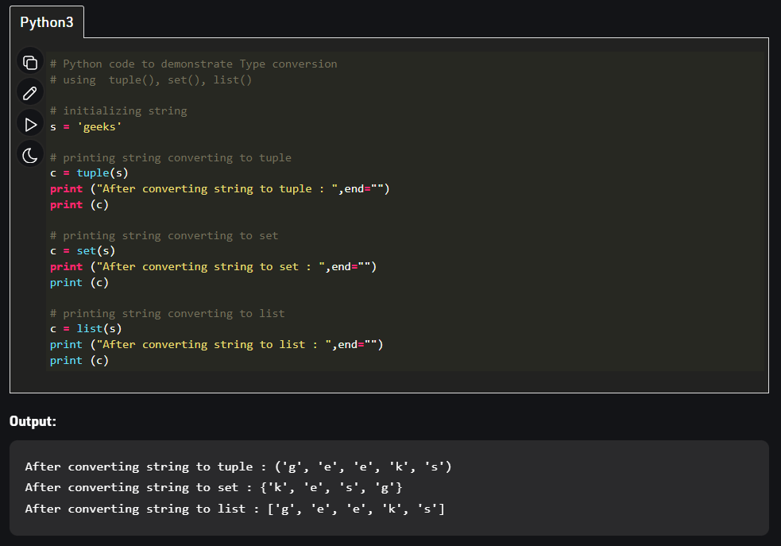

**9. dict() :**This function is used to **convert a tuple of order (key,value) into a dictionary**.  
**10. str() :**Used to **convert integer into a string.**  
**11. complex(real,imag) :**This function**converts real numbers to complex(real,imag) number.**

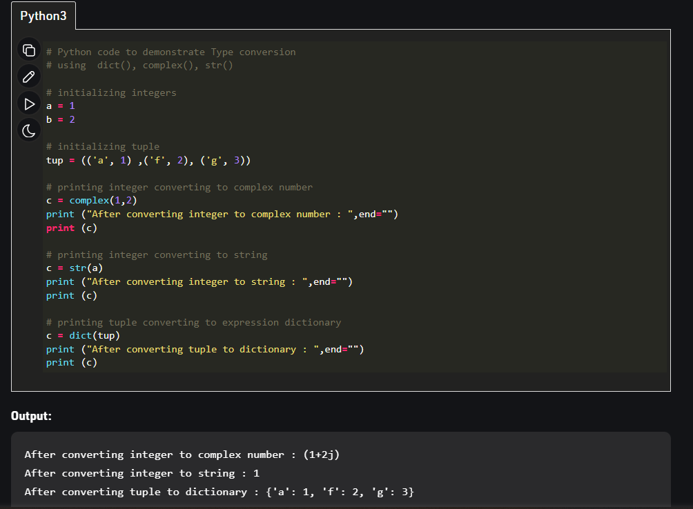

**12. chr(number):**This function**converts number to its corresponding ASCII character.**

